**Partner module**

**1.Delete account: In** this I delete my account and later I tried to login in that it shows warning message like activate mail-id account I clicked on this I got reactivation link for my respective mail id even though I got this still it’s loading in sign in page for all type of application (Mobile apk, mobile web) for my suggestion it should be stopped when I get the link, please find the below snapshot for the reference.

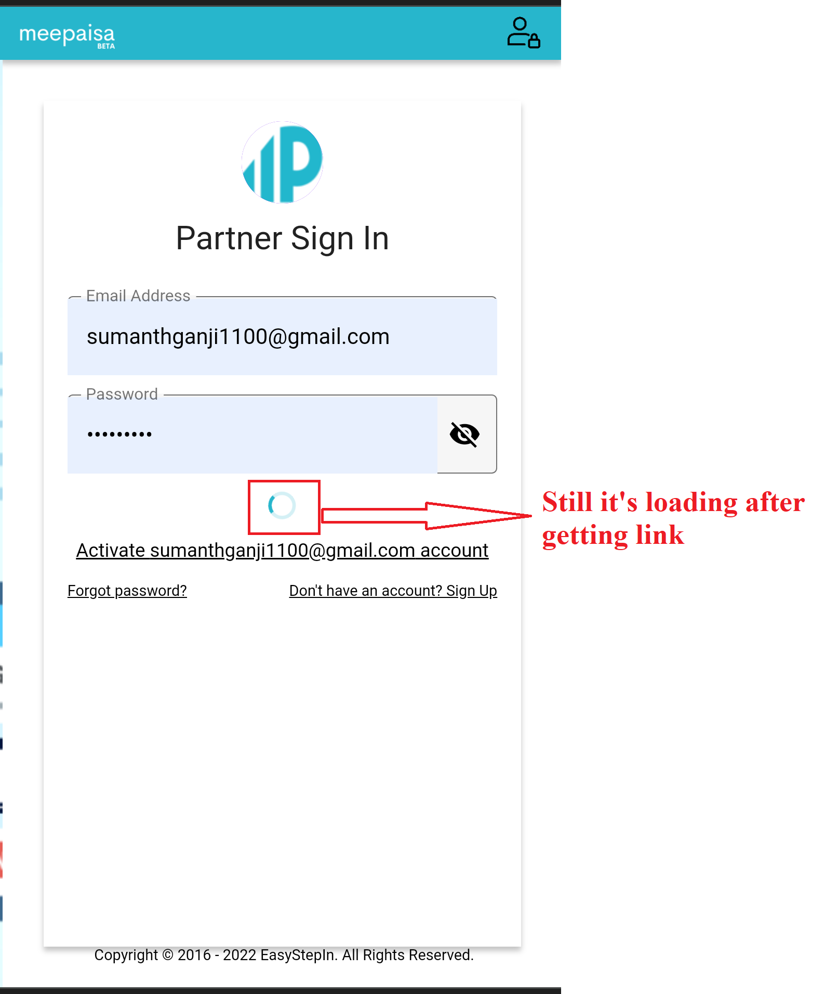

**2.** **Coupon management:** In this I clicked on add coupon enter all the details later I clicked on description it’s showing one enter URL link popup in that alignment issue is there please find the below snapshot for the reference.

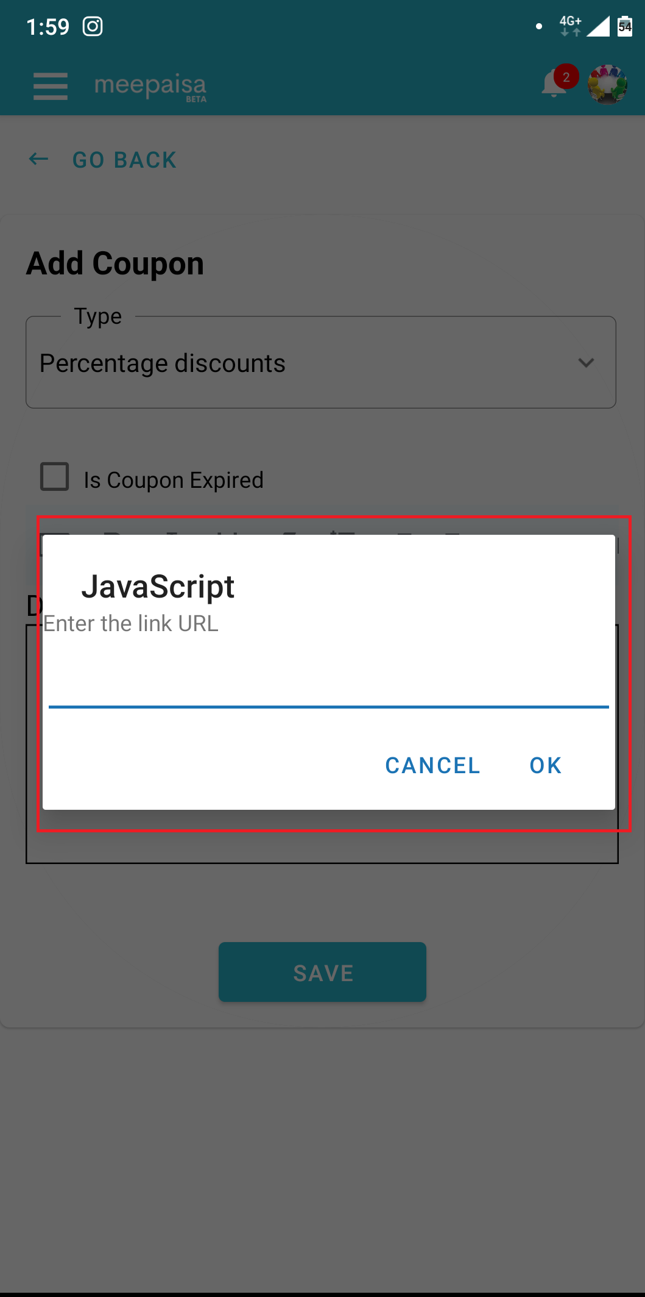

**3.Deal management:** In deal management I clicked on add deal in that

Description save button has UI issue please find the below snapshot for the reference.

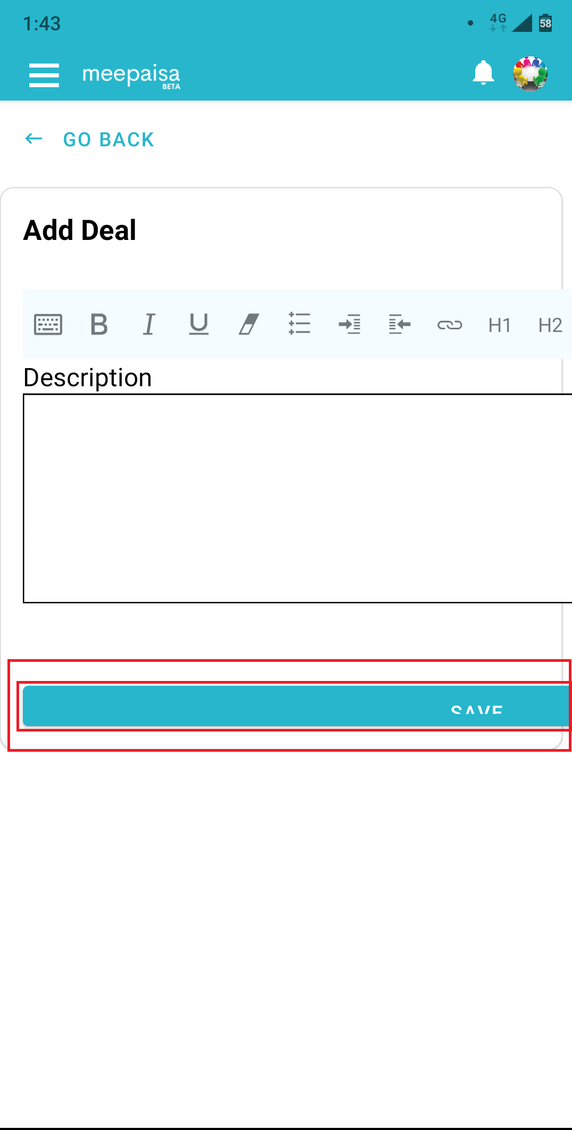

**4.Delete account:** I clicked on delete it displayed one confirmation message in that message has alignment issue please find the below snapshot for the reference.

*Alignment issue*

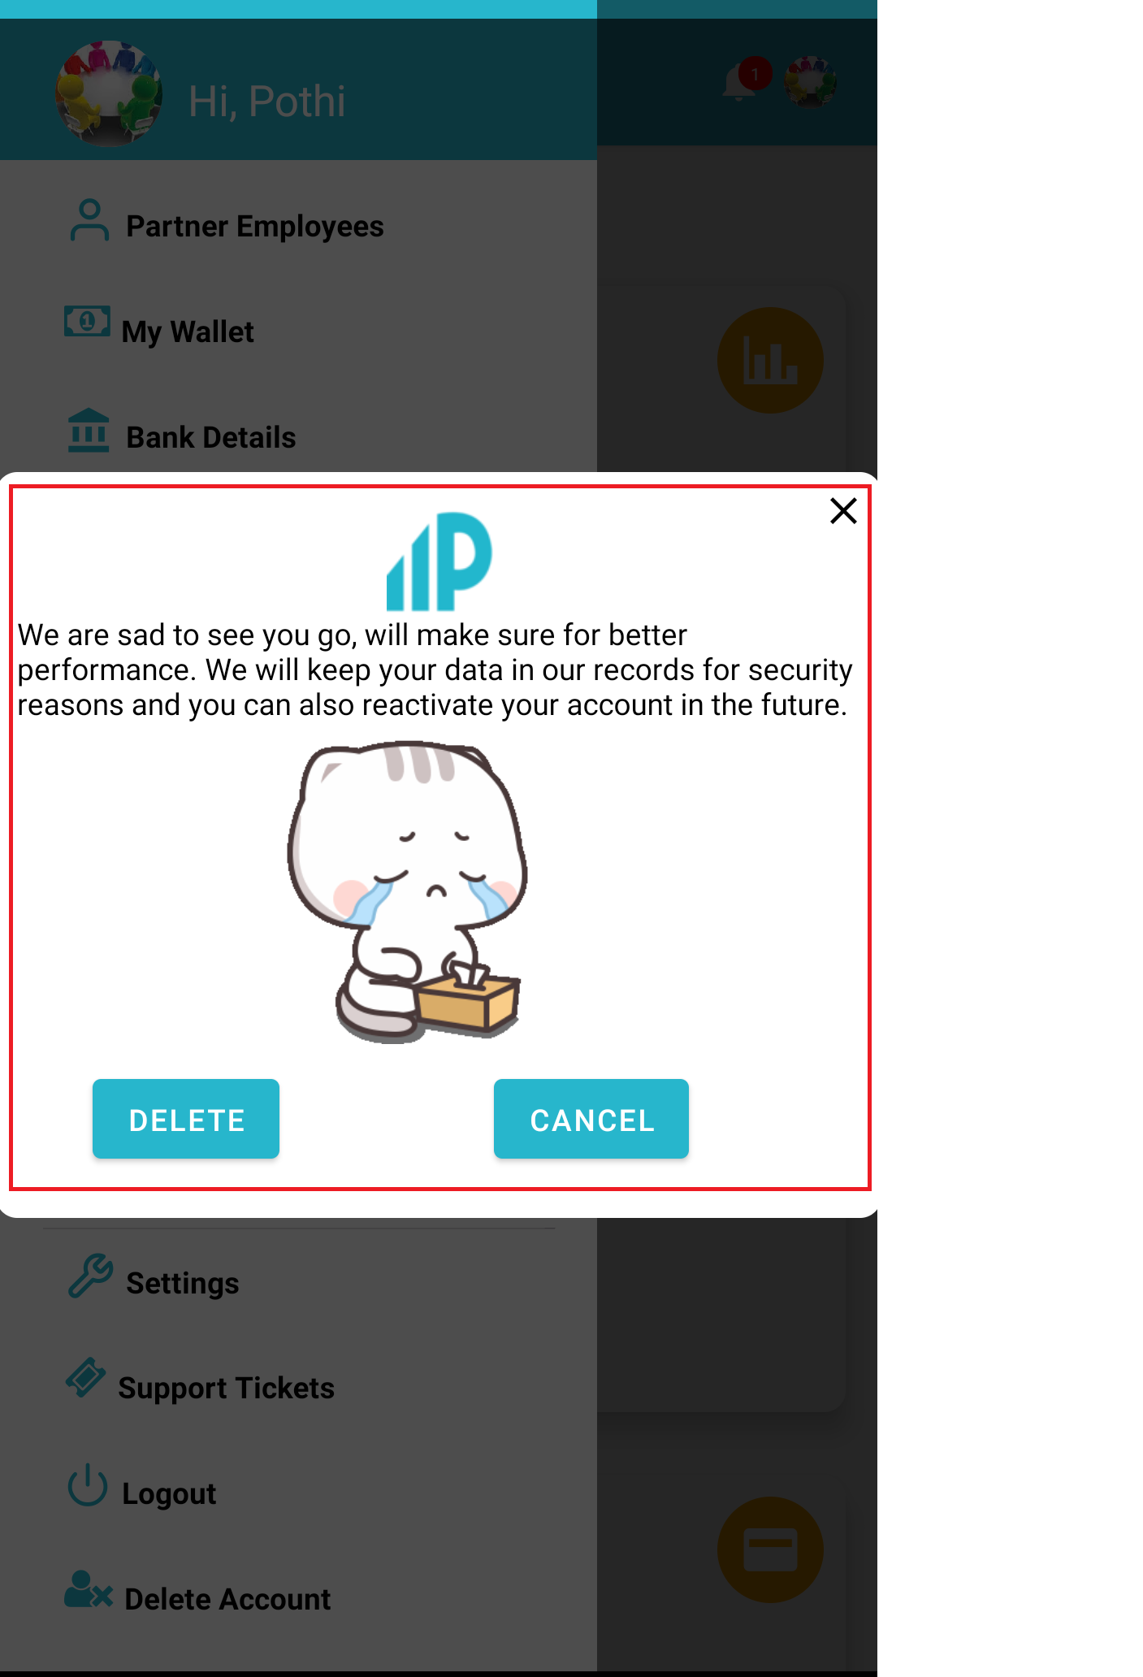

**5.Settings:** In add settings field name dropdown doesn’t have any values to select in all type of application (mobile apk, mobile web and web) please find the below snapshot for the reference

*Dropdown issue*

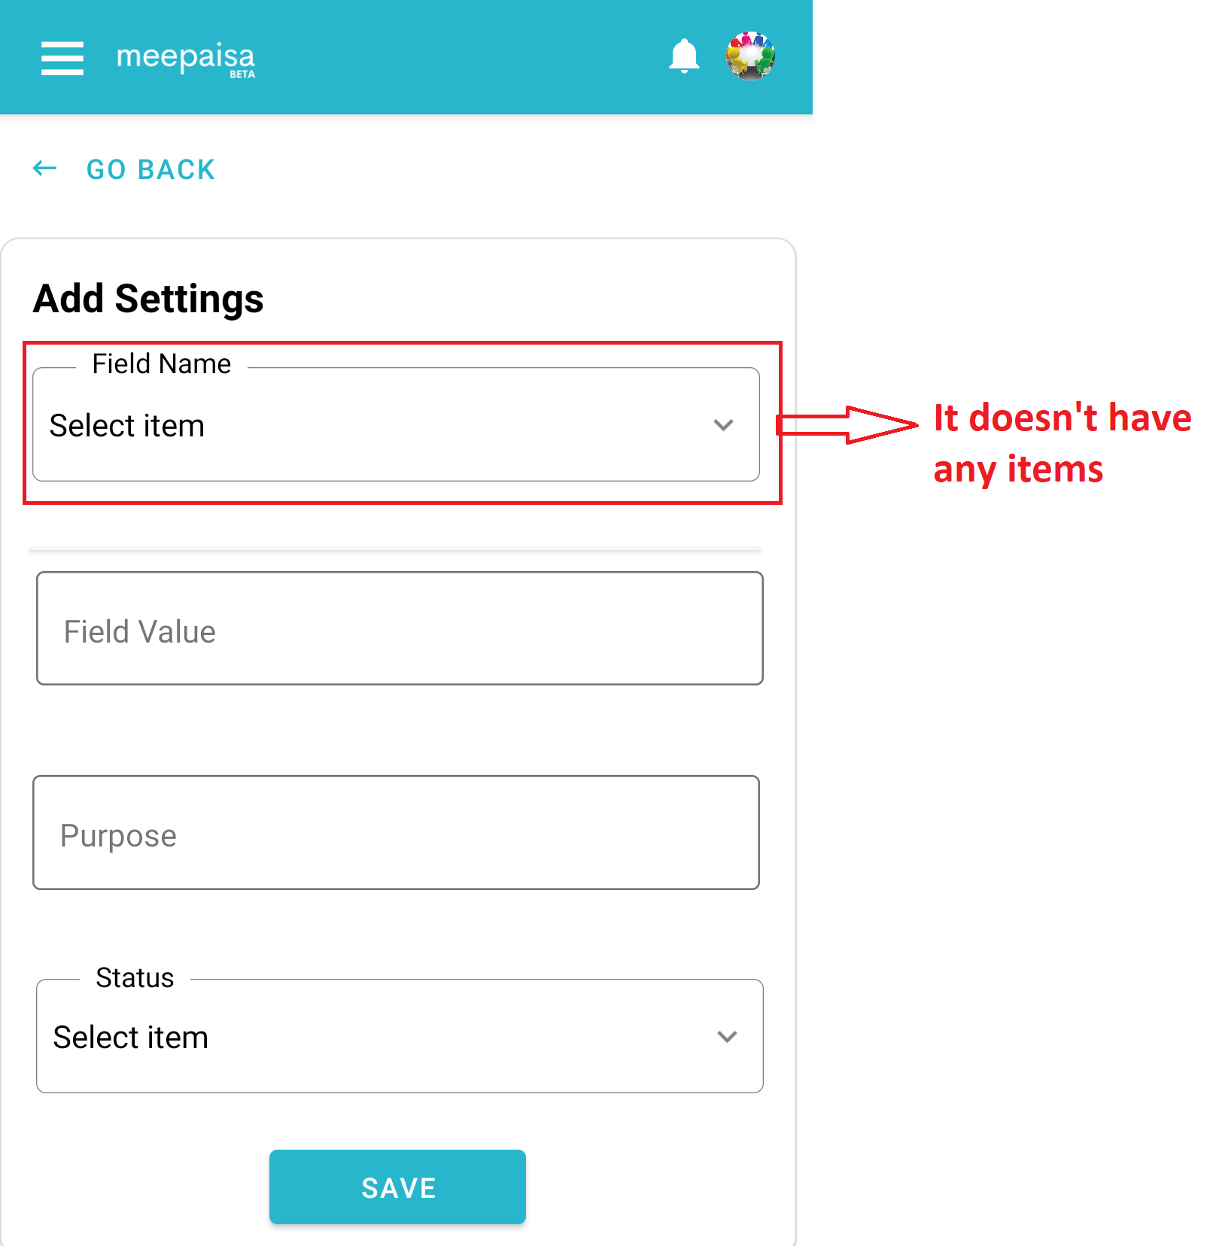

**6.Cart(B2C):** In cart I clicked on **+** sign to increasing quantity but it’s directly taking 100 quantity in all type of application **(Mobile apk**, **mobile web)** please find the below snapshot for the reference.

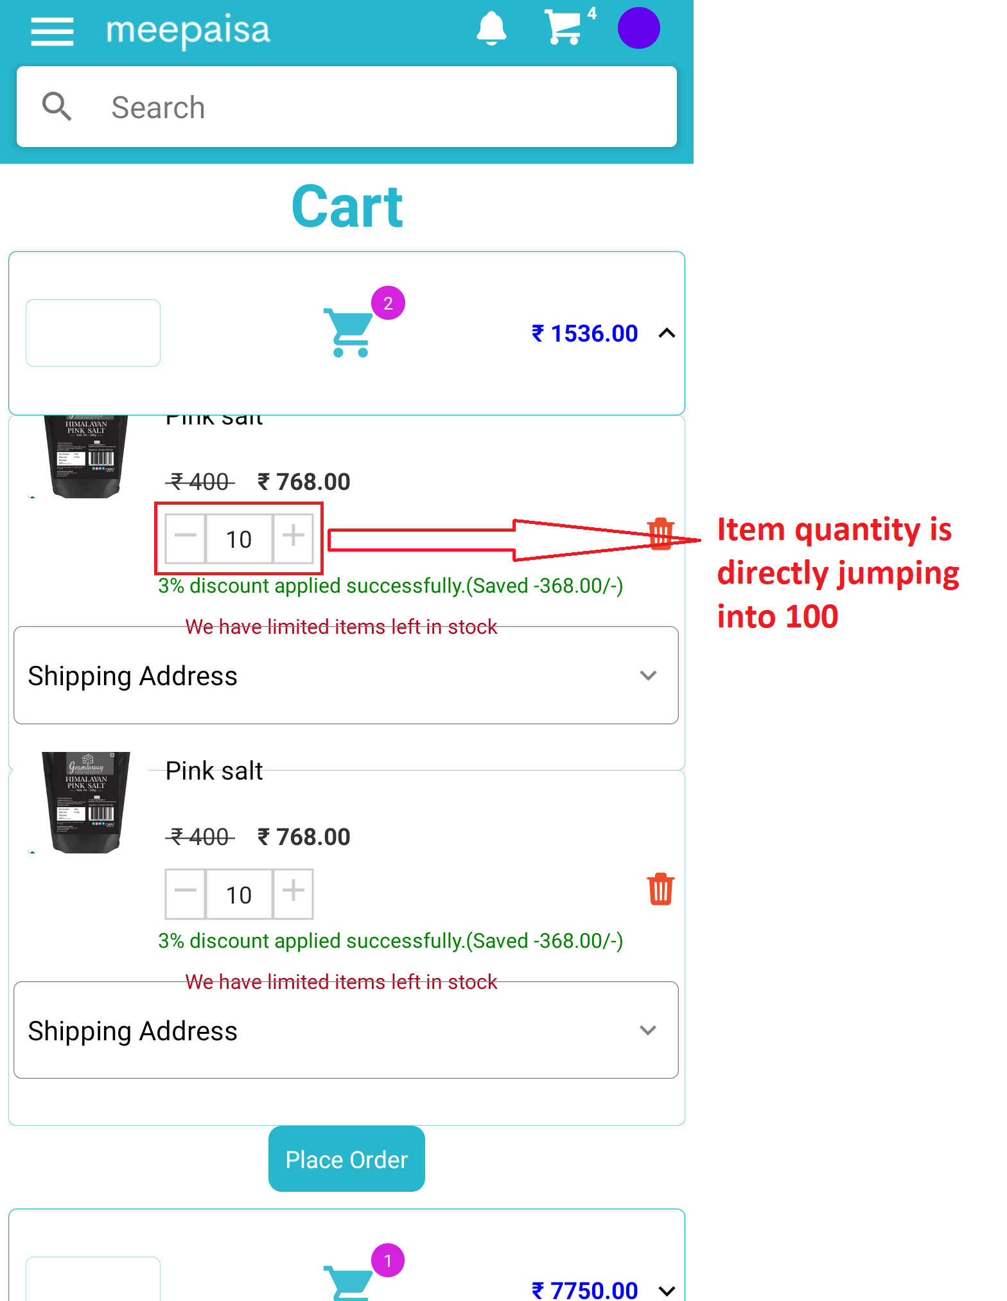

**7.Delivery agent details:** In this first name, last name and full name text fields accepting single and dual characters only in all type of applications **(mobile apk, mobile web and web)** my suggestion is we have to provide the limits for those fields please find the below snapshot for the reference.

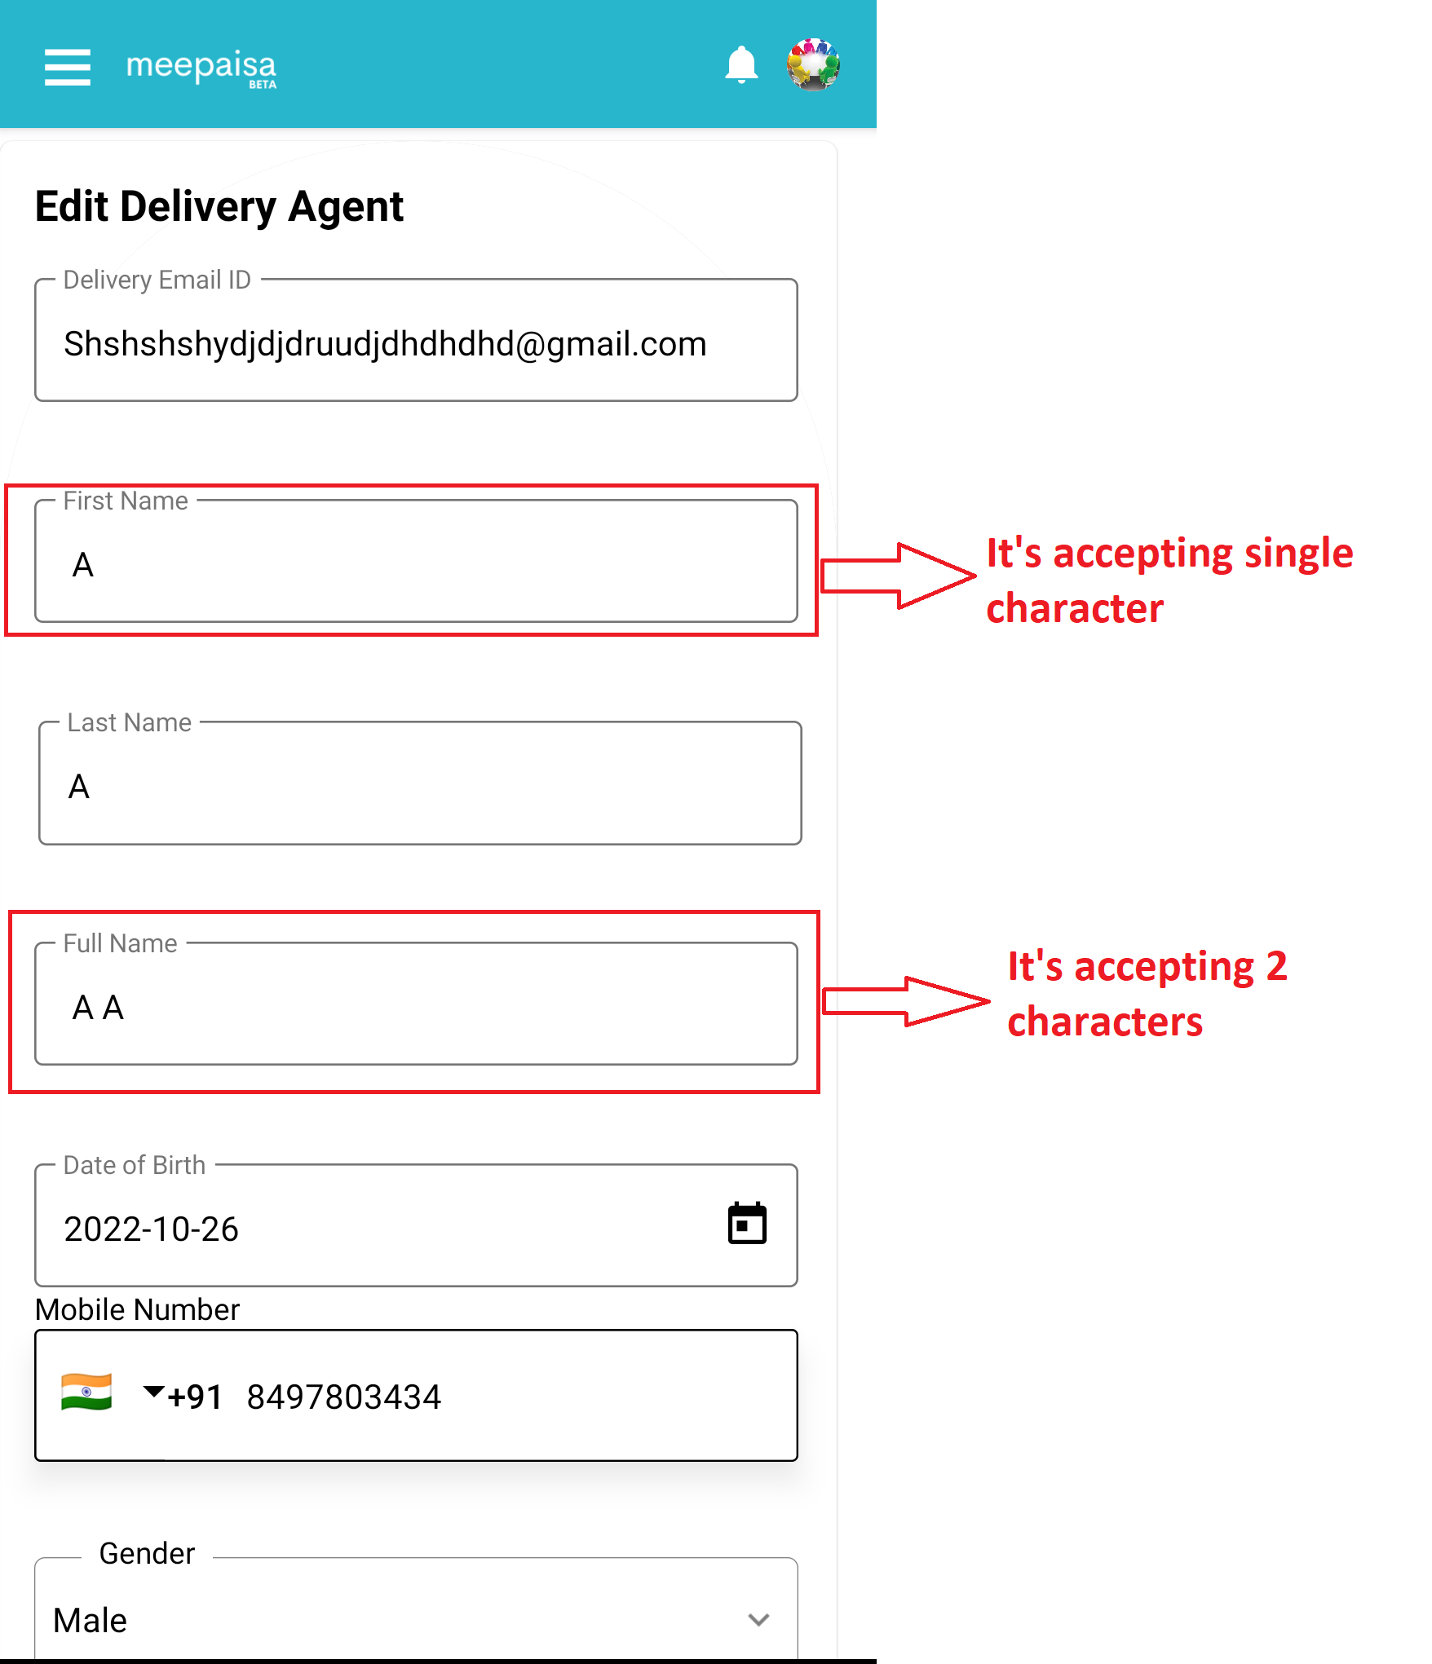

**8.Order management:** In order management in order history information at last no records added recently that recently word is not displayed fully it displayed partially in **mobile apk** please find the below snapshot for the reference.

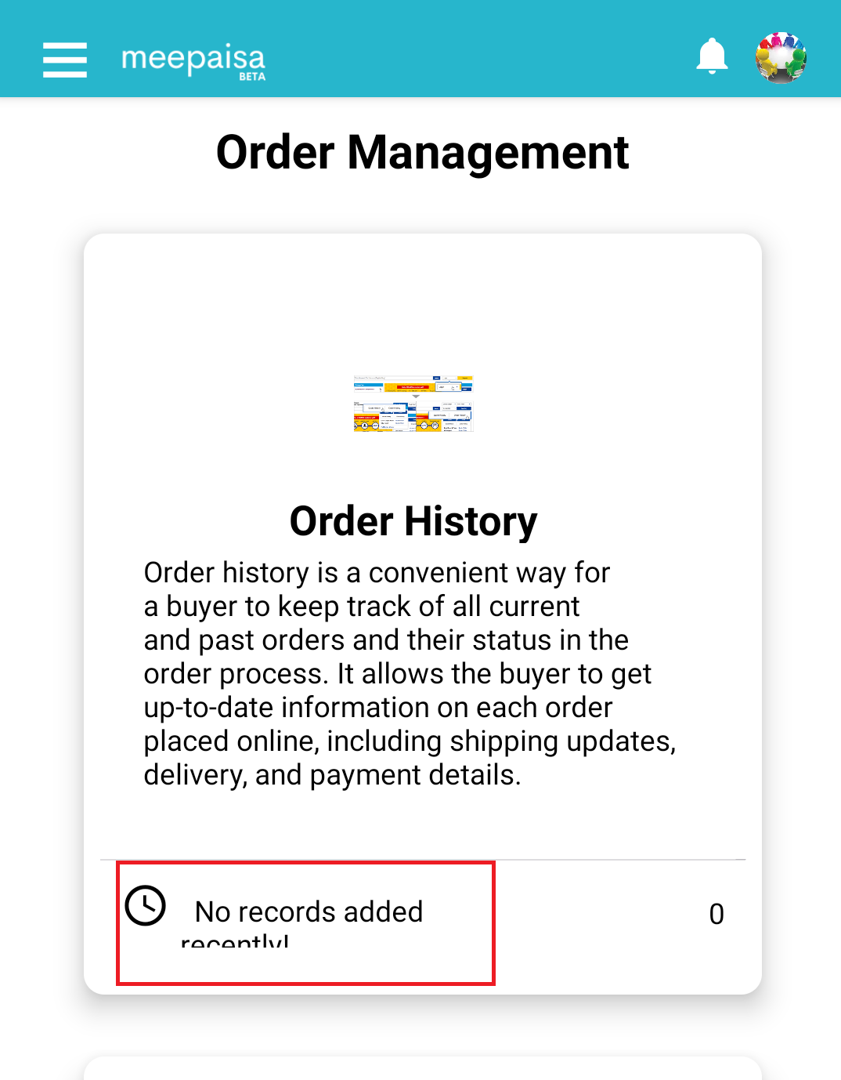

**9.Add to cart:** In this I added LG wash machine then I gone to cart in that LG different angle images list mobile images also there please find the below snapshot for the reference

