- SUPER ADMIN SESSION MANAGEMENT:
NO BLOCKERS, WORKING FINE
2. Super Admin - Delivery Agent Management Flow:
1.While creating delivery person in super admin not getting any emails (Node Api)
2. And also getting Internal server error, name field also accepting numbers and special characters, dob also accepting future dates
https://easystepinit-my.sharepoint.com/:v:/g/personal/vinay_duvvuru_easystepin_com/EQi91rV_sx9CkWNDUhttps://easystepinit-my.sharepoint.com/:v:/g/personal/vinay_duvvuru_easystepin_com/EQi91rV_sx9CkWNDUn5VJPkBtqmHs70n091mLAPNnpnAcw?e=ZpMgfGn5VJPkBtqmHs70n091mLAPNnpnAcw?e=ZpMgfG
3.Terms & conditions not selected even its accepting
3. Super Admin - Partner & Partner Employees Mangement Flow:
Billing email id not having proper validation
While creating a partner not getting any mails (Not getting any template ID).
Partner Employee by sign in a partner getting issue.
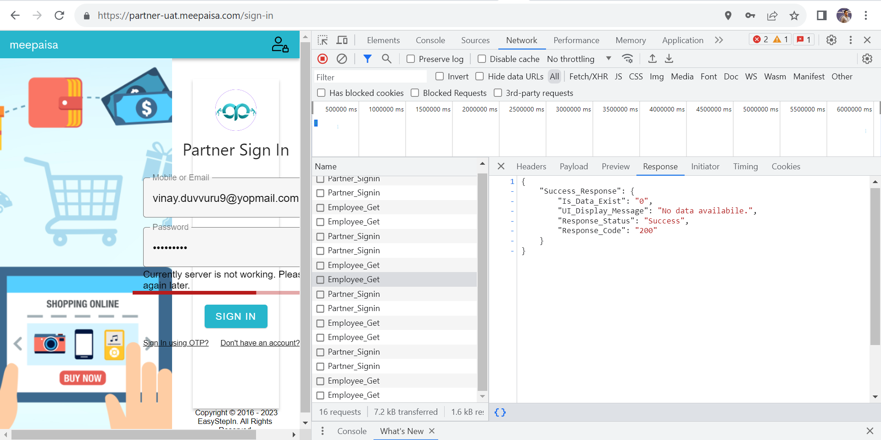

4. Deals Management:
1. User side city-based deals are not getting.
API: https://apiqa.meepaisa.com:9093/ws/rest/ESICB/Shop_By_City/City_List_Get Getting 404 error
2. Category field not providing but processing next page, please provide field validation.
3. Bad gateway 502 category is not provided.
4. Super admin side pending approval getting error 500 internal sever issue.

5. Gift Card Management:
1. User side create a gift card created successfully, but not getting mail Id vouchers.

6. Ride Vehicle
- While creating a vehicle not able to create, image field already providing a image again asking a image field is required.
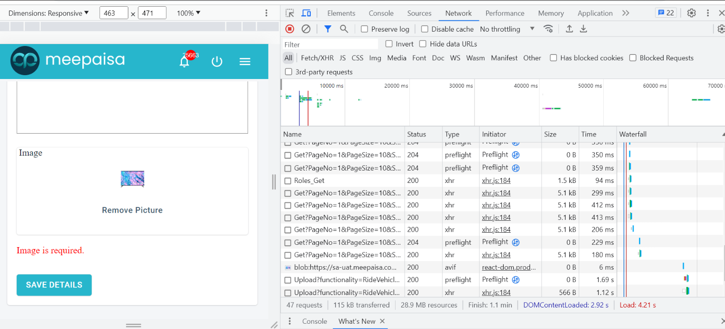
Same issue on delivery app also image field.
- While creating vehicles the text is not visible.
https://easystepinit-my.sharepoint.com/:v:/g/personal/vinay_duvvuru_easystepin_com/EfjeNuAcocJOjiVS1VUl00cBLL9OVR_9f0u4qZfMzu631g?e=wXFQbW
7. User Management:
Working fine.
8. Corp Coupon Order Management Flow:

Super Admin Issues Status:
- While creating delivery person in super admin not getting any emails – Node API Issue
- And getting Internal server error
- Name field also accepting numbers and special characters – No Characters Restriction
- DOB also accepting future dates – FIXED
- Terms & conditions not selected even its accepting – In Super Admin we are not providing validations for checkboxes
- Billing email id not having proper validation – Already given please check again
- While creating a partner not getting any mails (Not getting any template ID) - Boomi Issue
- Super admin side pending approval getting error 500 internal sever issue - Node API Issue
- While creating a vehicle not able to create, image field already providing a image again asking a image field is required – Already given please check again

